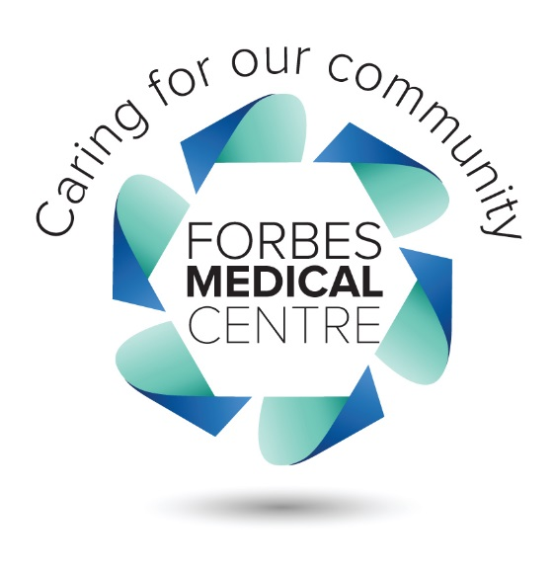

**Media Release**

**The Forbes Medical Centre stands out in education**

The Forbes Medical continues to strengthen its commitment to regional health services providing a unique and hands on training facility for University of Wollongong Medical students.

Tristan Scott and Shane Cameron moved to Forbes in June 2015 to complete the yearlong placement which is aimed at giving training doctors a more comprehensive and in depth knowledge about life and generalist medicine.

The placement is a part of a five year agreement between the FMC and the University of Wollongong which will see two third year medical students living and working in Forbes as part of their university studies.

“Most university programs only require medical students to undertake a 2-4 week placement but the opportunity to complete a twelve month placement at the one location really shapes these doctors,” FMC Practice Manager Beverlie Gardiner said. “The students become totally integrated into the day to day workings of our medical practice.”

Students are fortunate enough to see patients daily under the supervision of senior doctors as well as spend time working in the hospital and undertaking placements with community health services such as aged care and community nursing teams.

“This experience is invaluable as they have been able to follow up with patients to see the outcomes of their diagnosis and treatment plans,” Ms Gardiner said. “They have assisted with anaesthetics, procedures and minor surgery, even assisted with the delivery of local babies.

And it’s this hands on experience and the development of key relationships which encourages the doctors to come back once they complete their studies. “It is well established that students who train in the country, stay in the country and we hope that the students we train will be more likely to return to our practice at the completion of their studies.”

“The mentoring I have received here has equipped me with a broad range of skills, interests and perspectives that I will be able to use as I move into the workplace as a doctor in 2017,” Medical Student Tristan Scott said. “I will definitely be applying for a Junior Doctor (internship) position in the Central West and I would definitely like to work in a place like Forbes after I have built up my experience. The team at the Forbes Medical Centre are really in touch with community needs and have driven growth and positive changes for their patients. I am also grateful for all of the patients that I have met for taking the time to welcome me into the community and contribute daily to my education in so many ways.”

The FMC will be excited to introduce two new students in July at the conclusion of Tristan and Shane’s placement, with both training doctors recommending the experience to their peers.

“The people are friendlier and more welcoming and professionally the medicine is different,” Medical Student Shane Cameron said. “I would certainly recommend this experience not just to anyone thinking of practising medicine but to anyone studying medicine, I have very much enjoyed the enduring pleasures of life that Forbes has to offer.”